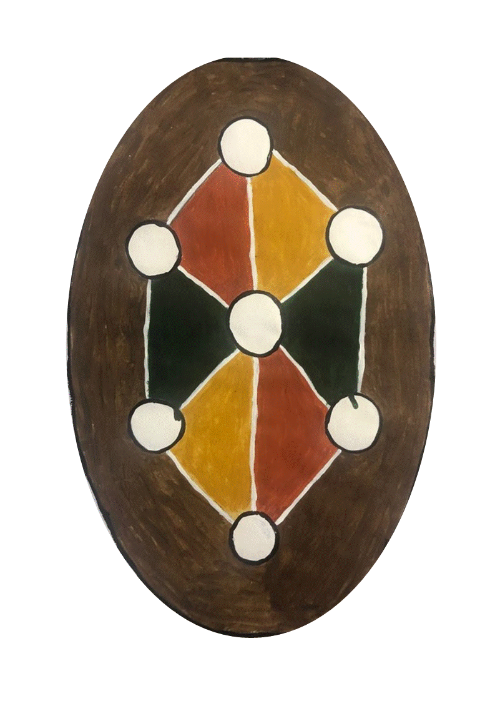 | Gugu Badhun Aboriginal Corporation RNTBC

Expressions of Interest
To be a part of Gugu Badhun Negotiation/Committee Teams
Casual Vacancies (multiple)
Various Projects
Background: From time-to-time Gugu Badhun Members have the opportunity to participate in different Negotiation Teams that will be for various projects within Gugu Badhun Aboriginal Corporation RNTBC. This requires a team of Gugu Badhun representatives to carry out meetings and work with external stakeholders to identify the best possible outcome for any areas that may contain Gugu Badhun areas affected by the different Negotiation projects.

Eligibility: You must be a Gugu Badhun person descended from one of the named apical ancestors to be eligible to apply:
- Bella, mother of Harry Goetz, Cissie McDowall, and Albert Brown;
- Lucy Shaw, mother of Richard Hoolihan, Mosely Dickman, and Jimmy Dickman;
- King Lava, father of Mariah Saddler;
- Tommy Cobbler; father of Nellie Rankin;
- Charlie Burdekin, father of Frank Burdekin, William Burdekin, Ernest Burdekin, Gertrude Burdekin, and Peter McDowell;
- Nancy Jordan, also known as Nancy Rose Lee and Nancy Ah Sam, wife of Harry Goetz;
- Nora Lee; also known as Laura and Laula, wife of Charlie Burdekin;
- Ceasar Murray;
- Minnie Tiger, also known as Big Minnie; and
- Skinny Minnie.

Gugu Badhun Negotiation/Committee teams:
If you wish to be considered to be a part of the Negotiation Teams:
- You must be a Member of the Gugu Badhun Aboriginal Corporation
- Must have access to a computer and internet, several meetings are on a web platform such as Microsoft Teams, Zoom or Google Duo.
- You will have to frequently check for updated correspondence relating to the negotiations details, most correspondence is through email.
- Be available for most of the Negotiation Meeting dates.

Term: Negotiations will be paid as a sitting fee for each meeting, so we do require that you sign a Letter of Engagement at the prior of the Negotiations. As the positions are for casual employment, there is no guarantee of ongoing or regular work.
Complete the Following: if you would like to be considered as one of the Gugu Badhun, please complete the details below:
Name
Date of Birth
Email Address
Postal Address
Residential Address
Mobile Phone Number
Home Phone Number
Name of your apical ancestor:

Write a brief description of your previous experience and what skills you bring for that position and what your interests are?

Attachments: Please attach any documentation that supports the qualities you would bring to a Gugu Badhun Negotiation Team. This may include a more complete resume; references; certificates etc.
To be considered to be a part of a Gugu Badhun Negotiation Team Register, this form must be completed and emailed to Gugu Badhun Aboriginal Corporation RNTBC to admin@gbac-rntbc.org.au

